EXPERIMENT 11
Link Jira tasks with Confluence to streamline task tracking and
progress monitoring for the Library Management System
development.
• Create a new page in Confluence titled &quot;Library Management
System Project Overview.&quot;
• Embed at least 5 Jira issues related to the development of the
Library Management System (e.g., tasks from the sprint like
&quot;Develop book search functionality,&Create user login page,&quot;
etc.).
• Use the Jira macro to display issues with status
• Add a progress bar in the Confluence page to visually track
the completion of each embedded Jira task (e.g., percentage of
tasks completed in the sprint).
• Submit a screenshot of the Confluence page showing the
embedded Jira tasks and the progress bar.

Step 1:Login in to Jira and click on space
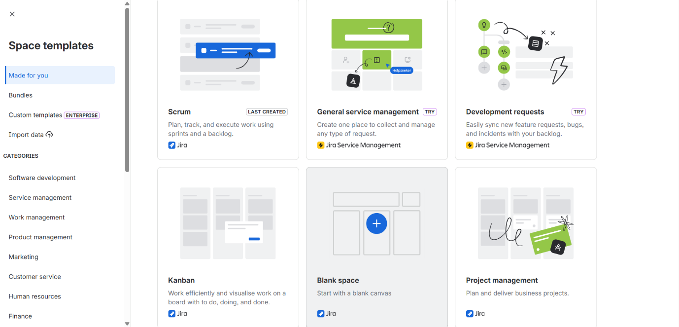

Step 2: Select kanban board

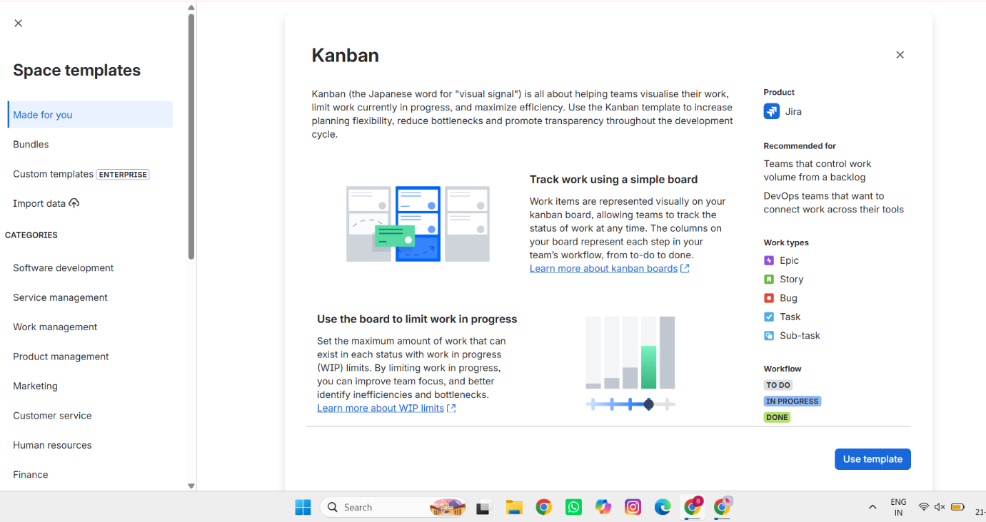

Step 3: Fill your project details in Name your space and click on next

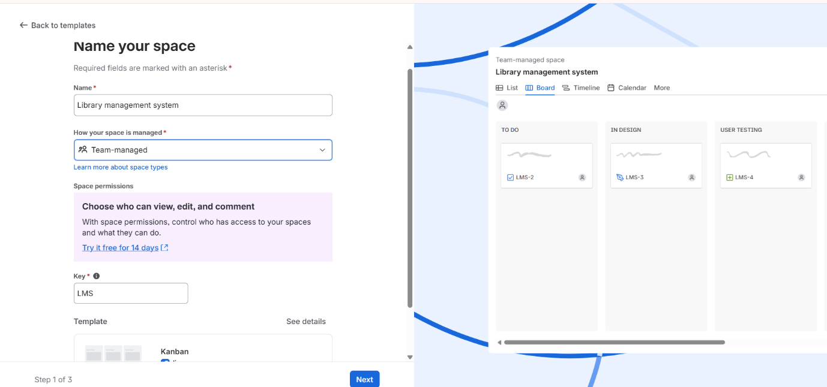

Step 4: Create tasks in list and assign them to team members
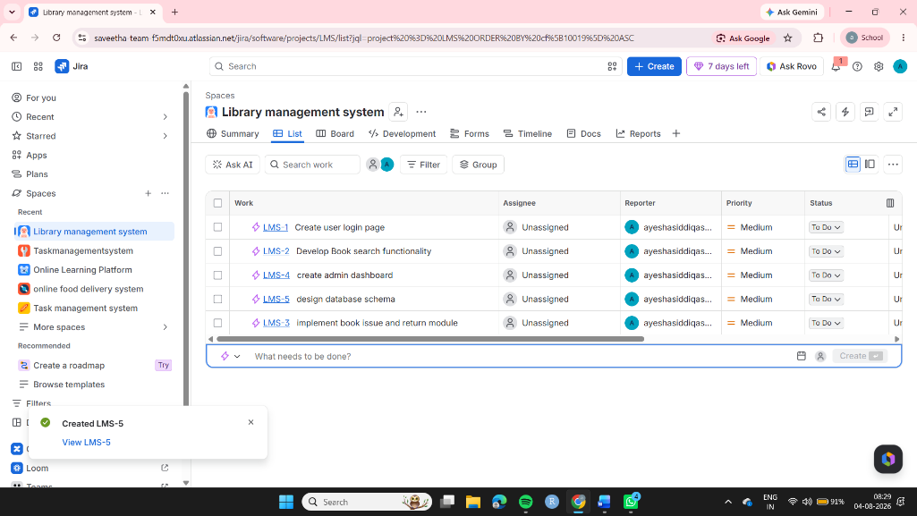
Step 5: Then assign the priority to the task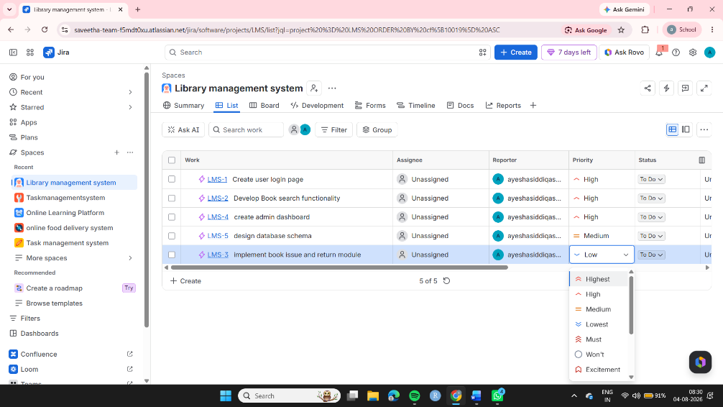

Step 6: from Jira now go to console and connect to the jira project
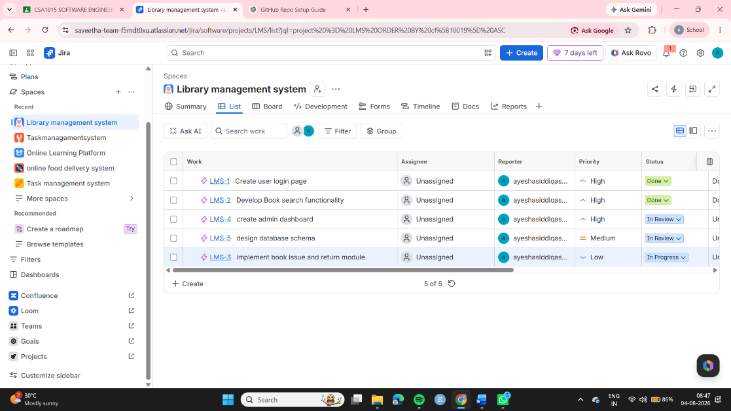
Step 7: Created page and embedded jira
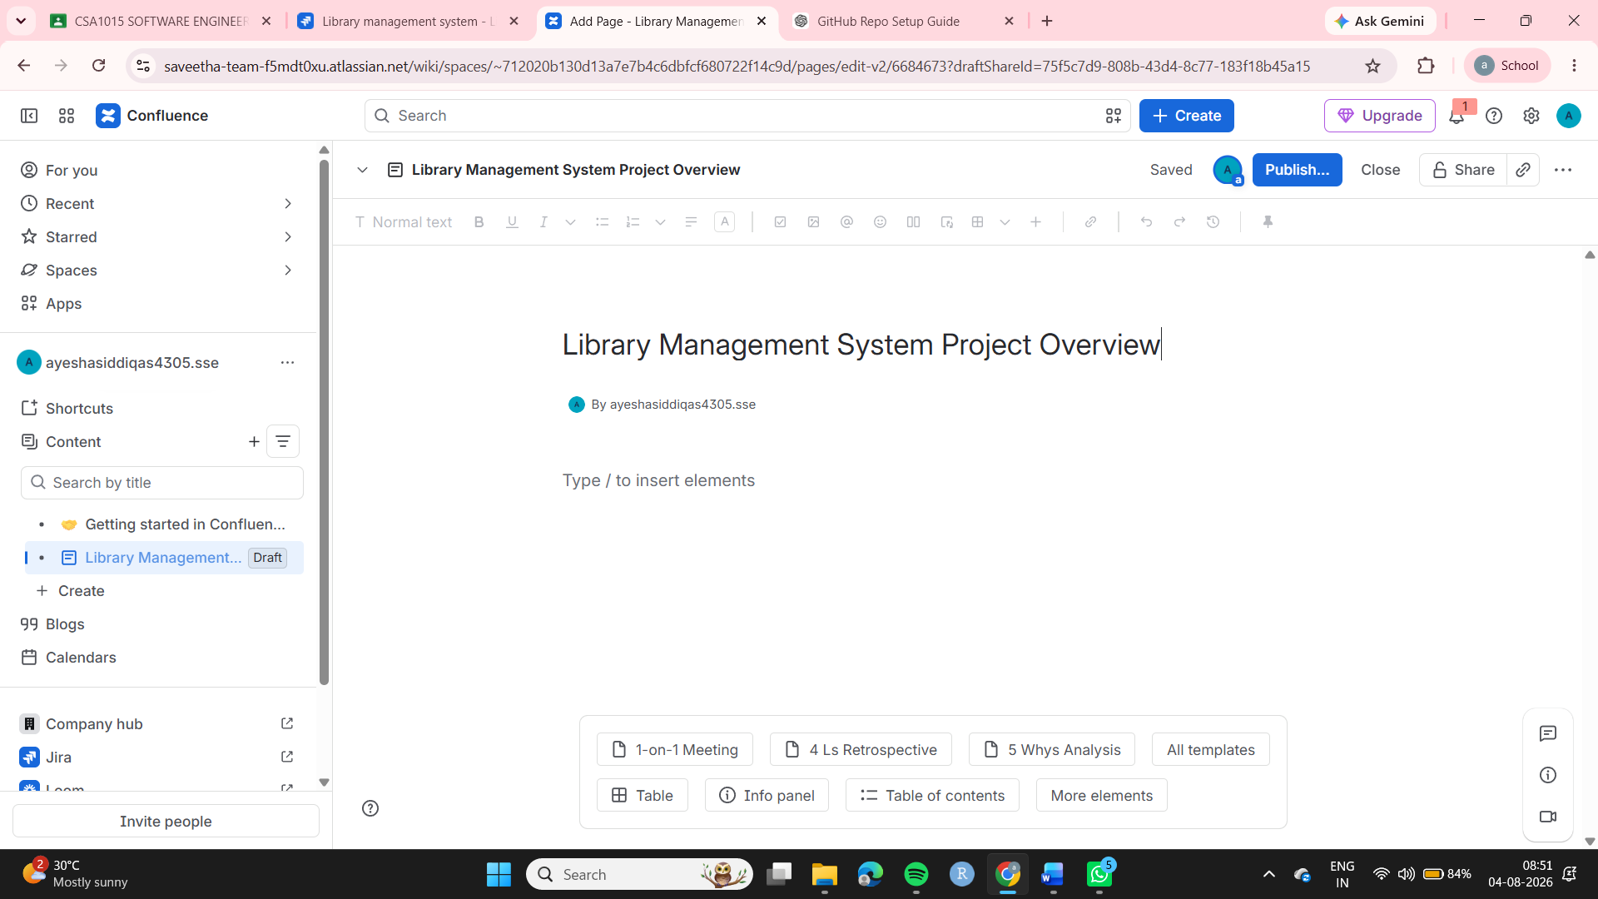
Step 8:Inserting jira issues
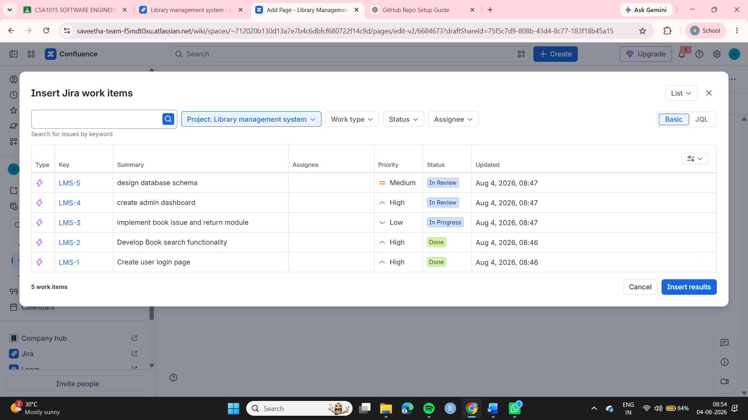
Step 9: published the issues
